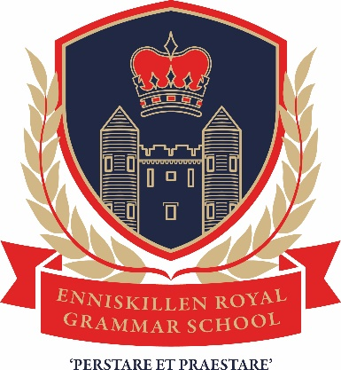
Application Form for entry to Sixth Form in Enniskillen Royal Grammar School in September 2021
Name: __________________________________ Form Class: 12_____
Please enter your choice of four subjects from the options available as indicated in the enclosed pages of the Sixth Form Prospectus. Please enter them in order of preference.
Choices | Subject at AS Level
First choice

Second choice

Third choice

Fourth choice

Reserve choices | Subject at AS Level
First choice

Second choice

Whilst every effort will be made to offer you the subjects you have selected, the decision to offer the subject will be dependent on numbers selecting each subject and the constraints of the timetable.
Please complete the section below should you intend not to return to school.
Destination: _______________________________________
Course: __________________________________________
Please complete and return this form by post to school or by e-mail to info@ergs.enniskillen.ni.sch.uk by Friday 28th May 2021
Pupil signature________________________________________
Parent’s/Guardian’s Signature: _____________________________

