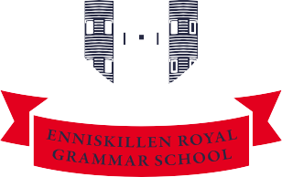
Enniskillen Royal Grammar School
Principal: Miss E. Armstrong BA (Hons) PGCE PQH(NI)

September 2021

Dear Parent/Guardian

I write in connection with the Lateral Flow Testing programme which the Department of Education, together with the PHA, are very keen to promote with all staff and pupils. Pupils test twice a week (Monday morning and Thursday morning before coming to school) and upload their results to an online portal. Today we spoke to your son/daughter’s year group in school to outline how the process works and to issue a consent form and an information leaflet which was issued to pupils in Years 12-14 at the start of the programme.

If you wish your son/daughter to participate in this voluntary programme we ask that you return the consent form to school by Tuesday 21st September 2021 and we will then issue your son/daughter with a Test Kit. I am aware that we had a good uptake among our pupils for these tests last term. However last term’s programme was a pilot one which is now concluded: pupils who wish to participate in this year’s programme should complete a new consent form.

I also take this opportunity to highlight a Flowchart for Parents which we have posted on our website and which is based on the NI Direct website guidance on the procedures to be followed if your child is identified as a close contact. We thank you for your continued cooperation as we implement this guidance within our school community. Your support in this is much appreciated.

If you have any queries or questions about any aspect of this letter, please do not hesitate to contact me at school.
Yours sincerely

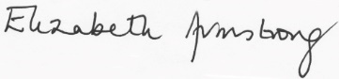

Elizabeth Armstrong
Principal

