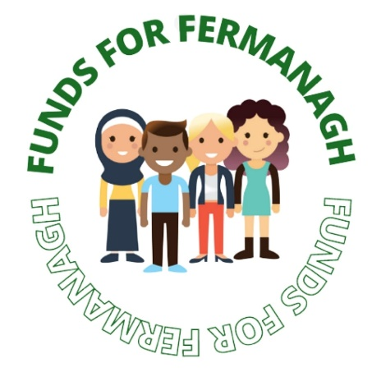
Funds For Fermanagh Information and
Guidance Notes

Funds for Fermanagh is a grant making group developed and being delivered by 6 young leaders, hoping to make a positive impact on the lives of other young people in Fermanagh.

The grant is set up under Fermanagh Trust and since forming, the group have agreed 3 significant areas in need of development in Fermanagh:

- Young People’s Personal Wellbeing
- Homelessness
- Poverty

With grants of up to £2,000 on offer, this is a fantastic opportunity for any group in the county.

Whether you are a school, youth group or an existing non-profit organisation, as long as you have passion for the potential Fermanagh has to offer, an idea of what you can do to make lasting, positive change and meet our simple criteria then we would love to hear from you!

Criteria For Applicants
- Your project must fall under at least one of our key areas as stated above.
- Potential projects must be located within County Fermanagh.
- Potential projects must not exceed £2000.
- Must be clear about the difference they would like to achieve.

Application Form:

Link to Application Form can be found on the Fermanagh Trust Website and on the Facebook and Instagram pages or by clicking the Link below:

Funds For Fermanagh Application Form: https://forms.gle/wfToaxdEEonagAaE6

Closing Date:
Applications must be sent via Google Form by:

Monday 14th March at noon (12pm).

Application Process

Once applications are received, the Funds For Fermanagh Team will shortlist.

Our team will respond via post to advise if you have been successful / unsuccessful at this stage of the process.

Successful applicants will be invited for interview on either
Saturday 26th March or Tuesday 29th March.

Once candidates have been interviewed, the team will then make our final decisions.

Applicants will be notified within 5 working days on whether they have been successful or not.

Successful Applicants will be notified of date to receive their Award and complete their Award Agreement.

Contact Details
For further information and questions please contact the team through:
Email Address: Fundsforfermanagh.info@gmail.com
Facebook: fundsforfermanagh2022
Instagram: fundsforfermanagh2022

