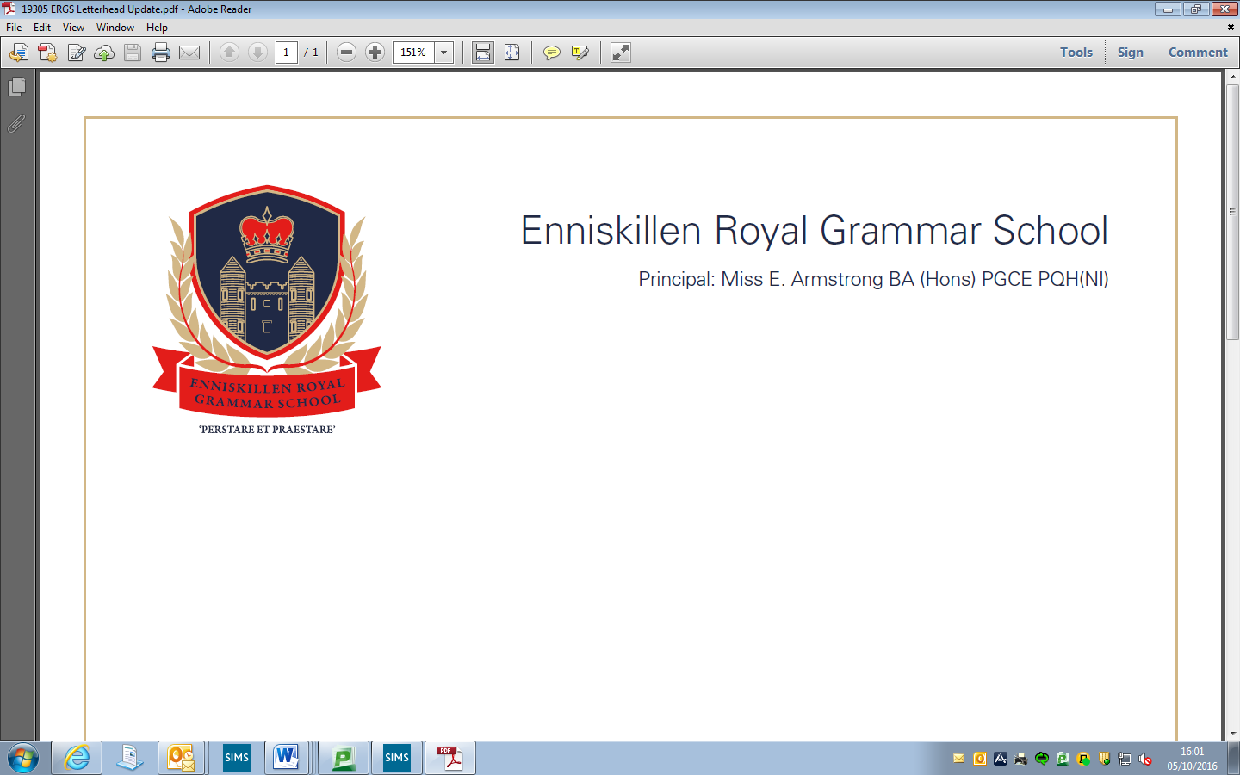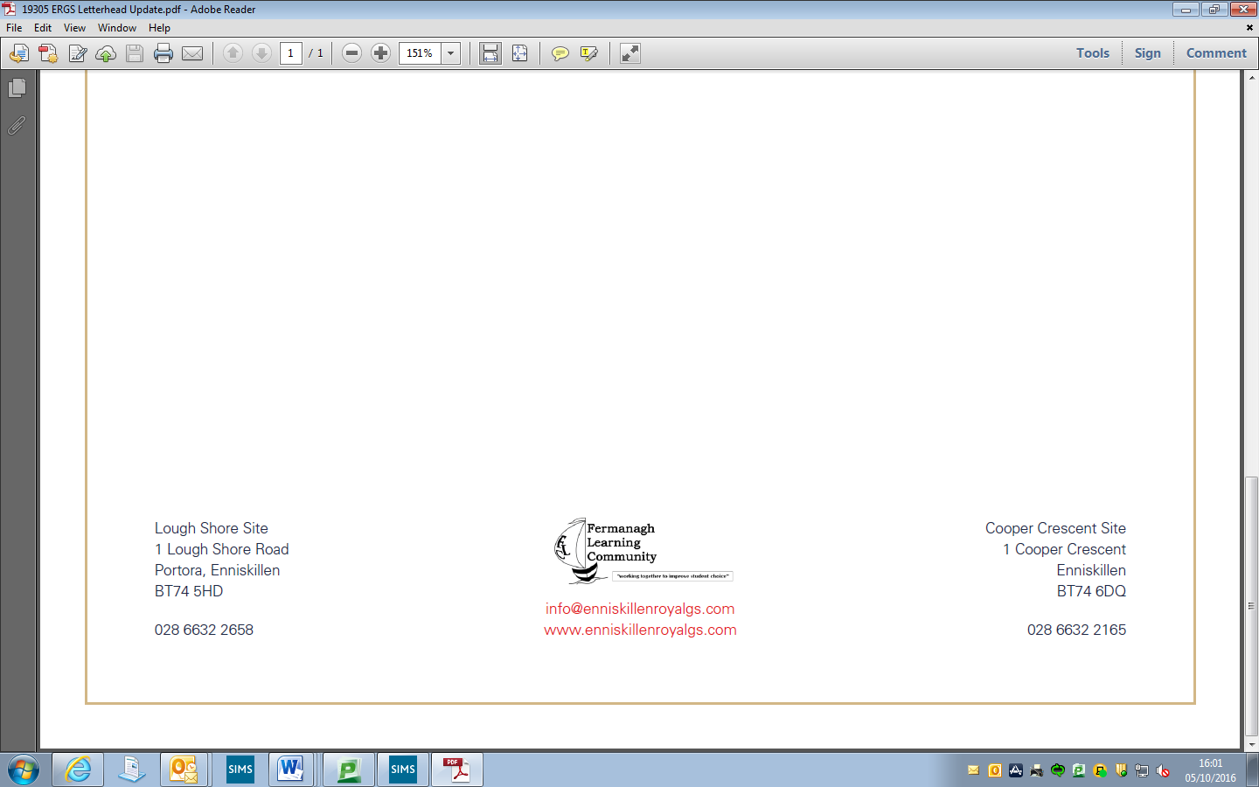

9th December 2024

Dear Parent/Guardian

You may be aware that in December 2020, the NI Executive agreed that free period products should be made widely available to pupils in primary and secondary schools. Subsequently, the Period Dignity Pilot Project was set up: Enniskillen Royal Grammar School is part of this Scheme.

Period dignity refers to the accessibility and availability of essential care needed to support menstruation, in conjunction with the removal of stigma and taboo around periods. Education is a key factor in breaking the stigma surrounding this and in promoting respect, understanding and open discussions about this key aspect of life.

The scheme also aims to tackle period poverty. The free products available through this scheme are not aimed at providing blanket provision, but to ensure products are available to those that need them, where and when they need them.

Over the coming weeks, the Period Dignity Scheme will be explained and discussed with Year 8 and 9 pupils through Year Group Assemblies, with follow-up question and answer sessions being facilitated in Tutor Time. Education around periods, in support of the scheme, will be delivered to pupils during Personal Development classes, in Tutor Time and within the Sixth Form Enrichment Programme.

At Enniskillen Royal Grammar School, we are providing free period products, both pads and tampons, in the girls’ toilets and in the disabled/all access toilets across both sites. Additional products are available on request from Reception. A Period Dignity Committee with representation from across all year groups has been established to assist in the roll-out of the scheme within school.

The school’s Period Dignity policy, drawn up in consultation with the School Council, was available on the school website for consultation by parents in 2022. For the benefit of the parents of Year 8 and new pupils to the school, the Period Dignity policy has been re-posted on the Enniskillen Royal Grammar School App. Alternatively, parents may request a copy of the policy from the Period Dignity Lead, Mrs Kettyle (Senior Teacher) by contacting her at school by telephone or via the school email account [info@ergs.enniskillen.ni.sch.uk](mailto:info@ergs.enniskillen.ni.sch.uk)

Please do not hesitate to contact Mrs Kettyle or myself if you have any questions or queries in respect of this letter.

Thanking you for your support in this important matter.

Yours sincerely

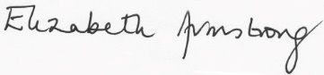

Elizabeth Armstrong

Principal