Enniskillen Royal Grammar School – CEIAG BULLETIN
Week Beginning Monday 16th March 2026
Destination Stem – Work Experience Placements
Destination STEM are offering paid one and two week placements in Construction in Enniskillen between 20th of July and 27th of August. You will work alongside industry specialists and take part in a supervised research project. You will be given travel expenses and £135 for each week you are on placement. Please visit stem.org/placements or email students@stem.org for an information and application pack. Closing date for applications is 20th April.
https://www.destinationstem.org.uk/get-involved/placements

XP Experiences in Tech - QUB
The School of Electronics, Electrical Engineering and Computer Science (EEECS) is offering 5 days of Work Experience to a cohort of 50 secondary students between the 8th – 12th June 2026.

The 5 day programme will provide students with the opportunity to experience a wide range of activities, including robotics, programming, VR/AR, electronics, a hackathon, as well as learning about the different careers’ options available to computing and electrical and electronic engineering students.

To be eligible, students must be:
- intending to take AS-Level or A-Level mathematics (Mathematics is essential for EEE subjects and desirable for Computing Subjects at Queen's)

- have an interest in either computer science (including software engineering, business information technology and computing information technology) and/or electrical and electronic engineering and computer engineering.)
https://www.qub.ac.uk/schools/eeecs/Study/work-experience/

Channel Talent Webinars with University of Glasgow Academics
Monday 23 March, 1245-1330: Mathematics/Computer Science: The Mathematics Behind AI with Dr Nicolas Pugeault from University of Glasgow
Mathematics/Computer Science: The Mathematics Behind AI with Dr Nicolas Pugeault from University of Glasgow - Channel Talent - Interactive school webinars
Thursday 26 March, 1245-1330: Geography: Who Makes a Place? – Tutorial with Dr Lazaros Karaliotas from University of Glasgow
Geography: Who Makes a Place? - Tutorial with Dr Lazaros Karaliotas from University of Glasgow - Channel Talent - Interactive school webinars
Army Work Experience 2026
A week packed with hands-on activities, challenges, and insight into Army life. It’s a fantastic opportunity for anyone interested in developing confidence, teamwork, and leadership skills.

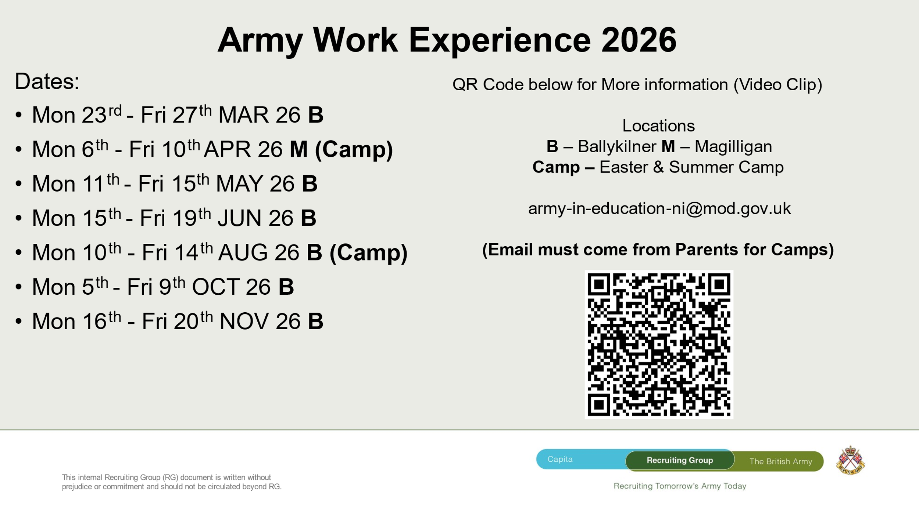
Royal College of Nursing Event – 25th March 2026
Royal College of Nursing are holding an event for those interested in Nursing or Midwifery at Belfast Met Titanic Quarter on 25th March 2026 from 2pm to 7pm. This event will be of interest to anyone thinking about studying nursing or midwifery in Northern Ireland. The programme will include information on entry requirements into the universities, explore alternative pathways into nursing, and highlight the wide range of opportunities that a career in nursing can provide.
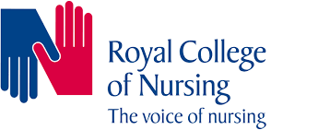
https://nisca.org.uk/wp-content/uploads/2026/02/RCN-NI-Pathways-into-Nursing-and-Midwifery-Programme-Brouchure.pdf
Registration Link
Future Medicines – Pharma & Biotech Careers (Student Event)
When: 26 March 2026 (6 – 9 pm)
Where: Whitla Hall, Queen’s University Belfast
Student Registration: https://www.qub.ac.uk/home/campaign/mhls/Events/pharmacy-insight-event-students/
This interactive event introduces students to the exciting opportunities offered by the BSc Pharmaceutical Sciences and BSc Pharmaceutical Biotechnology degrees at Queen’s, alongside the wide range of careers available in the pharmaceutical and biotech industries.
What students will experience:
- Insightful introductions to both BSc programmes and their associated career pathways.
- A Research Spotlight, showcasing cutting-edge scientific work within the School and how students engage with real-world discovery.
- A Student Panel, with current undergraduates sharing first-hand experiences.
- Networking opportunities with academic staff, industry experts, and student support teams
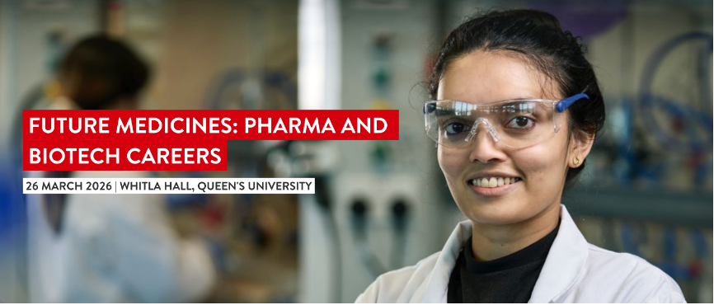

LJMU | Free (inc. flights) Year 13 Summer University: Wednesday 8 to Friday 10 July 2026 - Applications closing soon!
Year 13 Summer University, taking place from Wednesday 8 – Friday 10 July 2026. Students are urged to apply as soon as possible if they are interested in this year’s academic subjects: Law, Criminal Justice, History, Politics, or International Relations.
Summer University is free of charge and includes academic taster sessions, accommodation, meals and return flights from Belfast.
Additionally, students may be eligible for a reduced offer of up to 16 UCAS Points lower than the standard entry requirements, should they subsequently apply to LJMU.
Students can visit our Summer University website to find out more information and submit an application.

